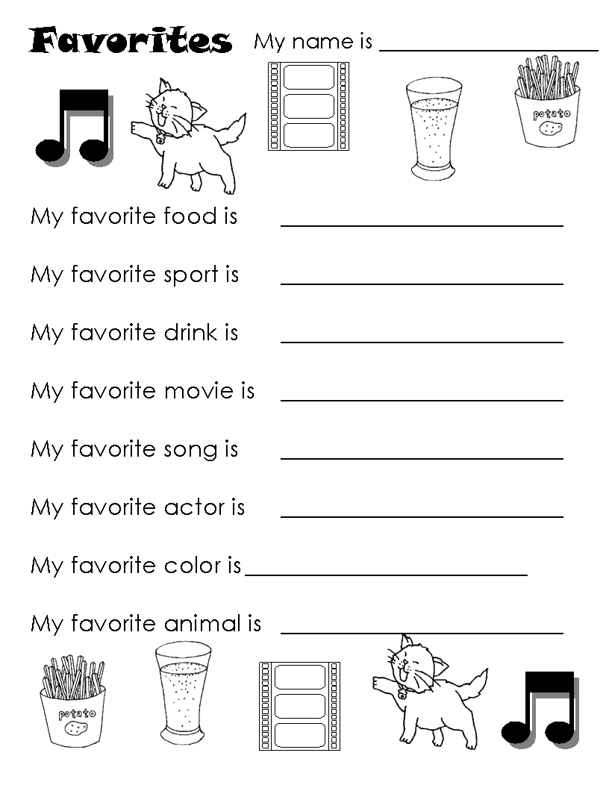

**His favorite ______________________________.**

**Her favorite _____________________________.**