TONGO polinezijska pesem
https://www.youtube.com/watch?v=wB-P13BgJBA

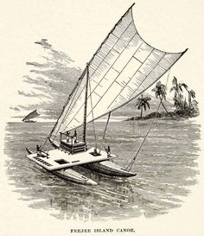

IN THE JUNGLE, THE MIGHTY JUNGLE THE LION SLEEPS TONIGHT
https://www.youtube.com/watch?v=CYDdUzL6-SM

In the jungle, the mighty jungle
The lion sleeps tonight
In the jungle, the mighty jungle
The lion sleeps tonight

Near the village, the peaceful village
The lion sleeps tonight
Near the village, the quiet village
The lion sleeps tonight

Hush my darling, don't fear my darling
The lion sleeps tonight
Hush my darling, don't cry my darling
The lion sleeps tonight

