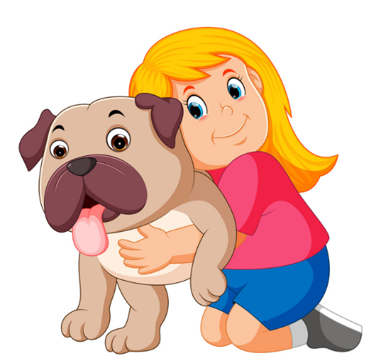
ANA

Besede v okvirju zapiši na prava mesta v besedilu. Poskusi glasno prebrati besedilo. Pomagaj si s posnetkom, ki si ga gledal/-a prejšnji teden.

color, name, my, 12, from, have, a sister

My _________ is Ana. I am ________ Poland. I have got __ _________ and a brother. My favourite ________ is purple. My hair is blond and ___ eyes are blue. I am ___. My sister is 16 and my brother is 15. I _______ got a cat, a dog, a hamster, spider and 6 fish.

